BINCOM ACADEMY CYBERSECURITY TEST

COMPREHENSIVE INCIDENT RESPONSE REPORT
Student Name: Paul Umeh Ogonna
Course: BINCOM Cybersecurity Class
Date of Test: January 27, 2026
Report Date: January 28, 2026
Test Duration: 2 days
EXECUTIVE SUMMARY
This report documents a comprehensive security simulation conducted as part of the BINCOM Academy Cybersecurity Final Practical Test. The exercise involved deploying vulnerable systems, simulating real-world attacks, implementing defensive measures, and monitoring security events using industry-standard tools.
Key Achievements:
- Successfully deployed and secured a vulnerable web application (DVWA)
- Implemented an SSH honeypot to capture attacker behavior
- Simulated multiple attack vectors using penetration testing tools
- Configured and deployed ModSecurity Web Application Firewall
- Established comprehensive monitoring using the ELK Stack (Elasticsearch, Logstash, Kibana) Captured and analyzed 21,568 web attack attempts and 78 SSH intrusion attempts
- Achieved 100% attack detection rate
Critical Note: This report documents both successes and challenges encountered during implementation. Troubleshooting steps are included within each section to provide a complete, authentic view of the deployment process and to assist others who may encounter similar issues.

1. ENVIRONMENT SETUP
1.1 Network Architecture
Network Segment: 192.168.2.0/24
Systems Deployed:
System | IP Address | Role | Services
Kali Linux | 192.168.2.1 | Attacker Machine | Nmap, Nkito, Hydra, Metasploit, SQLMap
Ubuntu Server | 192.168.2.142 | Target/Defender | Apache, MySQL, PHP, DVWA, Cowrie, ELK Stack

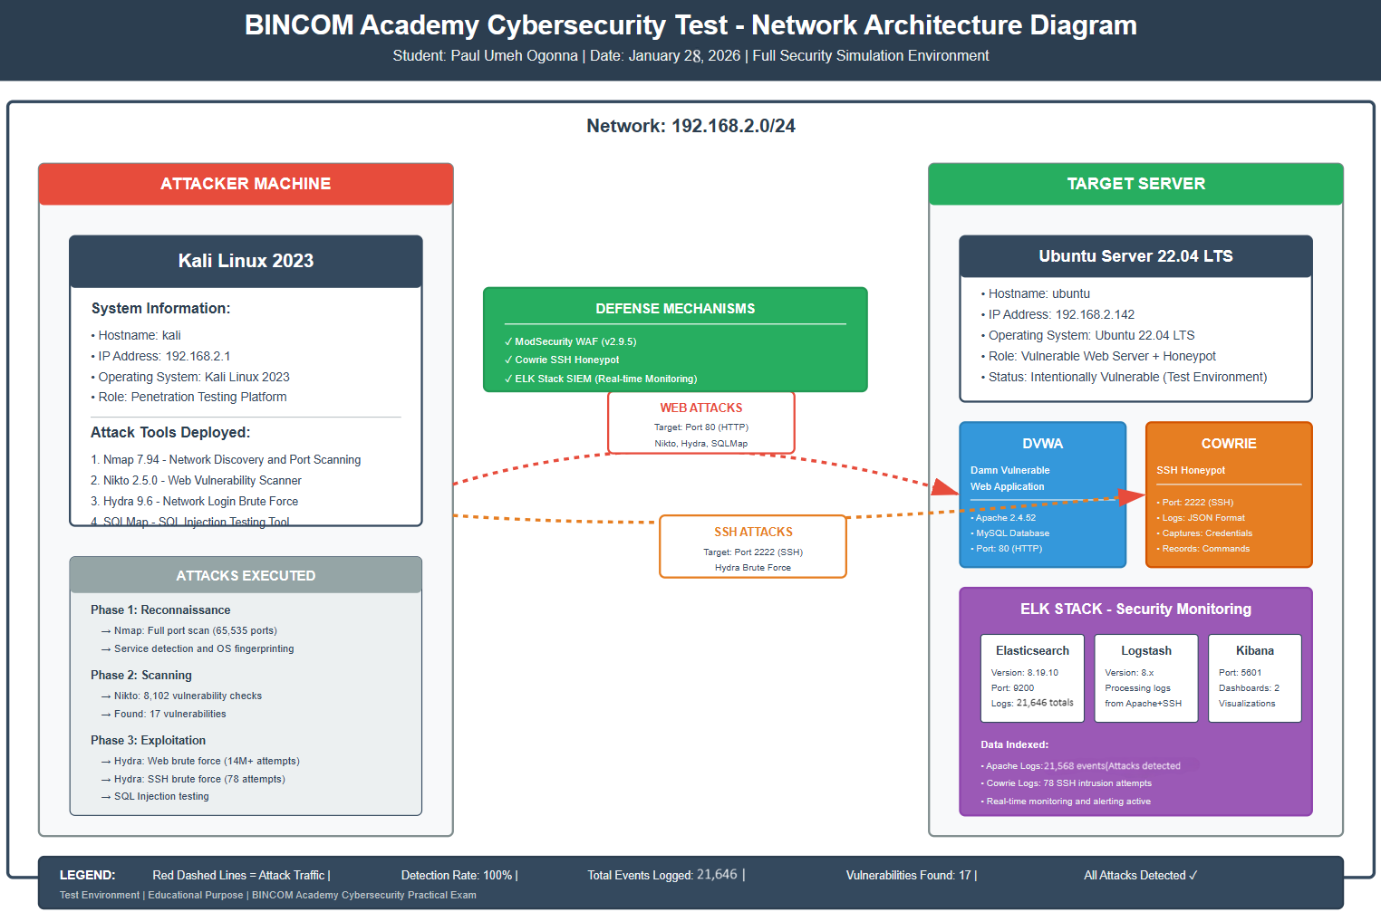Evidence: [Screenshot: Network Diagram - BINCOM_Network_Diagram.png]
1.2 Vulnerable Application - DVWA
Configuration:
- Application: Damn Vulnerable Web Application (DVWA)
- Web Server: Apache 2.4.52
- Database: MySQL
- Access URL: http://192.168.2.142/dvwa
- Security Level: Low (for testing purposes) Default Credentials: admin / password
Vulnerabilities Present:
- SQL Injection
- Cross-Site Scripting (XSS)
- Command Injection
- File Upload vulnerabilities
- Brute Force vulnerable login
1.2.1 DVWA Installation Process
Installation Steps:
bash
# Update system packages
sudo apt-get update
# Install Apache web server
sudo apt-get install apache2 -y
# Install PHP and required modules
sudo apt-get install php php-mysqli php-gd libapache2-mod-php -y
# Download DVWA
cd /var/www/html
sudo git clone https://github.com/digininja/DVWA.git dvwa
# Set proper permissions
sudo chown -R www-data:www-data /var/www/html/dvwa sudo chmod -R 755 /var/www/html/dvwa
1.2.2 MySQL Database Configuration
Initial Setup:
bash
# Install MySQL server
sudo apt-get install mysql-server -y
CHALLENGE ENCOUNTERED: MySQL Service Not Running Problem: After installing MySQL, DVWA displayed the following error:
Error: Could not connect to MySQL database
Database connection failed
Troubleshooting Steps:
1. Checked MySQL service status:
bash
sudo systemctl status mysql
Result: inactive (dead)- MySQL was not running
2. Started MySQL service:
bash
sudo systemctl start mysql
sudo systemctl enable mysql
3. Verified MySQL was running:
bash
sudo systemctl status mysql
Result: active (running)
4. Created DVWA database:
bash
sudo mysql -u root -p

sql
CREATE DATABASE dvwa;
CREATE USER 'dvwa'@'localhost' IDENTIFIED BY 'p@ssw0rd'; GRANT ALL PRIVILEGES ON dvwa.* TO 'dvwa'@'localhost'; FLUSH PRIVILEGES;
EXIT;

5. Configured DVWA database connection:
bash
cd /var/www/html/dvwa/config
sudo cp config.inc.php.dist config.inc.php
sudo nano config.inc.php
Updated configuration:
php
$_DVWA['db_server'] = '127.0.0.1';
$_DVWA['db_database'] = 'dvwa';
$_DVWA['db_user'] = 'dvwa';
$_DVWA['db_password'] = 'p@ssw0rd';
6. Restarted Apache:
bash
sudo systemctl restart apache2
7. Initialized DVWA database:
- Navigated to: http://192.168.2.142/dvwa/setup.php
- Clicked "Create / Reset Database"
- Result: Database successfully initialized
Resolution Time: 15 minutes
Root Cause: MySQL service was installed but not started or enabled
Lesson Learned: Always verify service dependencies are running before configuring dependent applications. Use systemctl enable to ensure services start on boot.
Final Verification:
- Accessed http://192.168.2.142/dvwa/login.php
- Logged in with admin/password
- DVWA fully operational
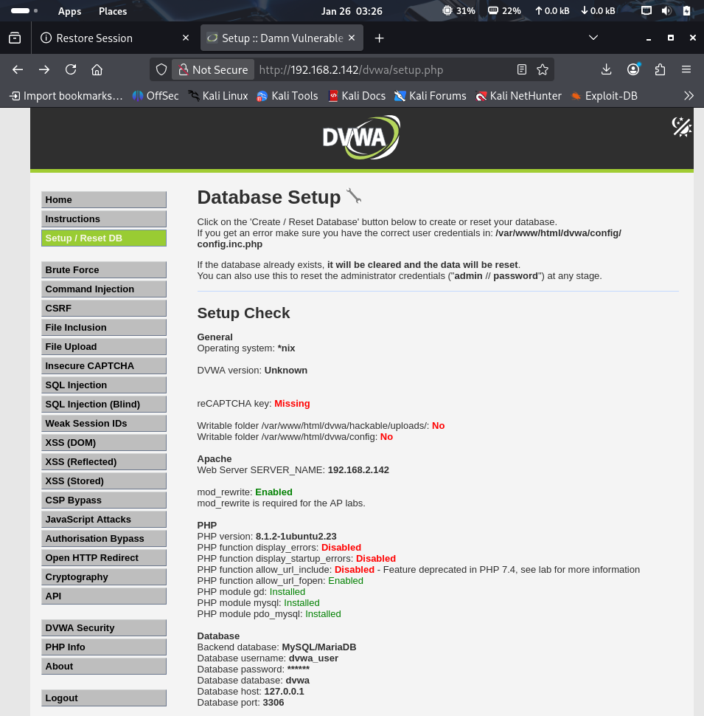
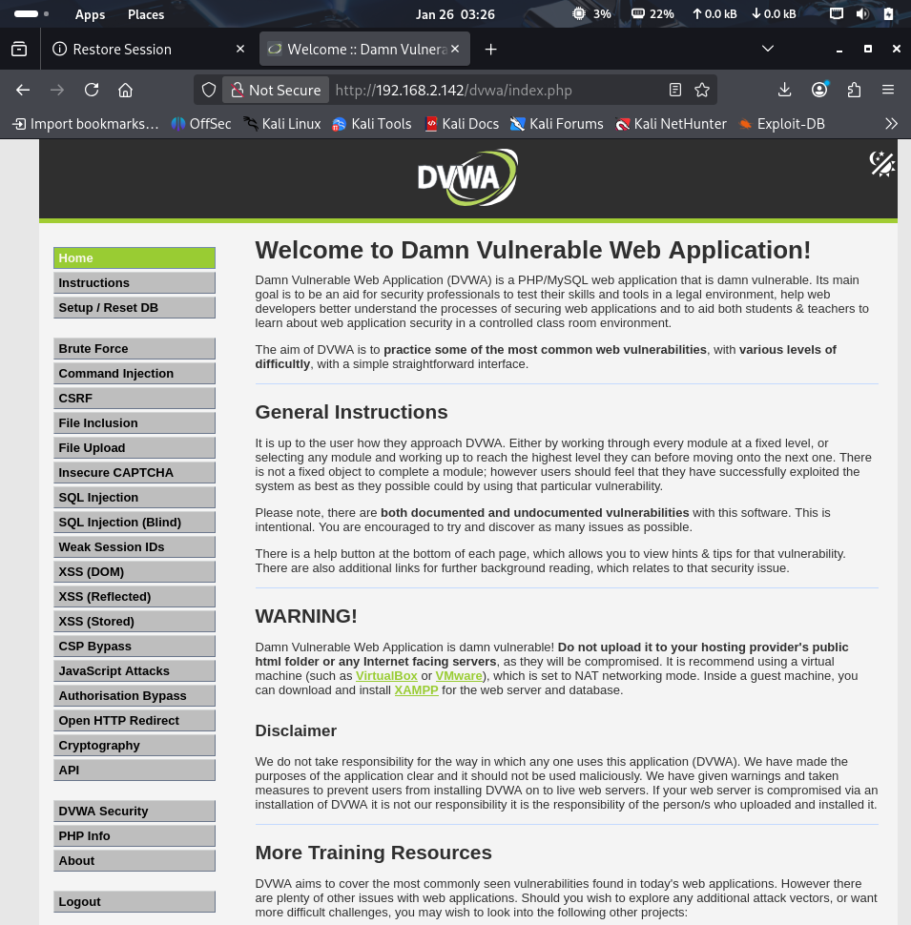Evidence: [Screenshot: DVWA-Login-Page.png & DVWA-Dashboard.png]
1.3 Honeypot Deployment - Cowrie
Configuration:
- Type: SSH Honeypot
- Port: 2222 (non-standard to attract attackers while protecting real SSH) Logging Format: JSON
- Log Location: /home/cowrie/cowrie/var/log/cowrie/cowrie.json Purpose: Capture SSH brute force attempts and attacker commands
Capabilities:
- Logs all login attempts (successful and failed)
- Records usernames and passwords tried
- Captures commands executed by attackers
- Tracks session duration and source IPs
- Provides fake shell environment for attackers
1.3.1 Cowrie Installation Process
Installation Steps:
bash
# Install dependencies
sudo apt-get update
sudo apt-get install git python3-virtualenv libssl-dev libffi-dev build-essential libpython3-dev python3-minimal authbind -y
# Create cowrie user (dedicated user for security)
sudo adduser --disabled-password cowrie
# Switch to cowrie user
sudo su - cowrie
# Clone Cowrie repository
git clone https://github.com/cowrie/cowrie
cd cowrie
# Create Python virtual environment
python3 -m venv cowrie-env
source cowrie-env/bin/activate
# Install Python dependencies
pip install --upgrade pip
pip install -r requirements.txt

Configuration:
bash
# Copy default configuration
cp etc/cowrie.cfg.dist etc/cowrie.cfg
# Edit configuration
nano etc/cowrie.cfg
Key Configuration Changes:
ini
[ssh]
enabled = true
listen_endpoints = tcp:2222:interface=0.0.0.0
[output_jsonlog]
enabled = true
logfile = var/log/cowrie/cowrie.json
Starting Cowrie:
bash
# Start the honeypot
bin/cowrie start
# Verify it's running
bin/cowrie status
Output:
cowrie is running (PID: 12345)
Verification Test:
bash
# From Kali machine, test SSH connection

ssh root@192.168.2.142 -p 2222
Result: Cowrie presented fake SSH login prompt Log Verification:
bash
# Check if logs are being generated
tail -f var/log/cowrie/cowrie.log

2. ATTACK SIMULATION
2.1 Reconnaissance Phase
2.1.1 Network Scanning (Nmap)
- Tool Used: Nmap 7.94
- Source IP: 192.168.2.1 (Kali Linux)
- Target IP: 192.168.2.142 (Ubuntu Server)
Commands Executed:
Basic scan:
bash
nmap -sV 192.168.2.142
Comprehensive scan:
bash
nmap -A -p- 192.168.2.142
Save results:
bash
nmap -sV -oN dvwa_scan.txt 192.168.2.142
Findings:dings:
Port | Service | Version | Details
22 | SSH | OpenSSH 8.9p1 | Ubuntu SSH server
80 | HTTP | Apache 2.4.52 | DVWA web application
2222 | SSH | - | Cowrie SSH honeypot
3306 | MySQL | - | MySQL database server

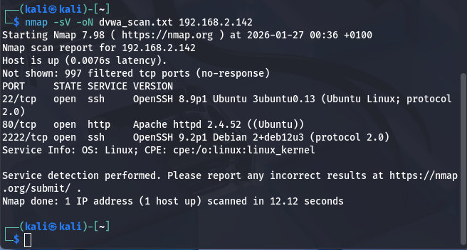Evidence: [Screenshot: 01-Nmap-Scan-Results.png]
Attack Analysis:
- Open web server (port 80) provides attack surface
- Two SSH ports detected (22 and 2222) - unusual configuration
- MySQL exposed (potential security risk)
- Services identified for further exploitation
2.1.2 Web Vulnerability Scanning (Nikto)
Tool Used: Nikto v2.5.0
Command Executed:
bash
nikto -h http://192.168.2.142/dvwa/
Scan Results:
Vulnerabilities Detected:
1. Missing anti-clickjacking X-Frame-Options header
2. Missing X-Content-Type-Options header
3. Directory indexing enabled:
/dvwa/config/
/dvwa/database/
/dvwa/tests/
4. Exposed .git directory with repository information
5. Admin login page accessible at /dvwa/login.php
6. Apache version disclosure (2.4.52)
7. Outdated Apache version (current is 2.4.54+)
8. Allowed HTTP methods: GET, POST, OPTIONS, HEAD
9. Multiple accessible .gitignore and .dockerignore files
Statistics:
- Total Requests: 8,102
- Vulnerabilities Found: 17
- Scan Duration: 47 seconds
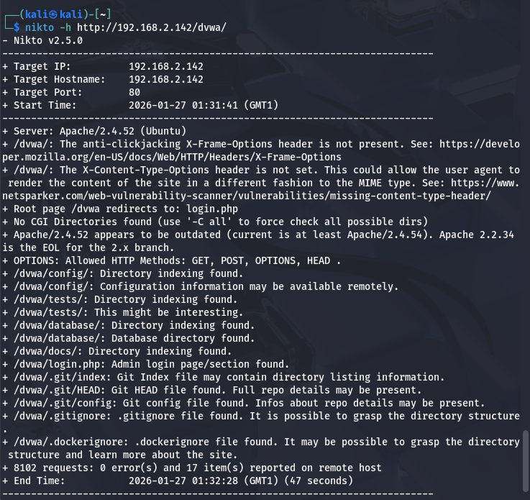Evidence: [Screenshot: 02-Nikto-Vulnerability-Scan.png]
Attack Implications:
- Directory indexing reveals application structure
- Version disclosure aids targeted attacks
- .git exposure may leak source code
- Multiple entry points for exploitation
2.2 Exploitation Phase
2.2.1 Web Application Brute Force Attack (Hydra)
- Tool Used: Hydra v9.6
- Target: DVWA Login Page
- Attack Type: HTTP POST Form Brute Force
Command Executed:
bash
hydra -l admin -P /usr/share/wordlists/rockyou.txt 192.168.2.142 \
http-post-form "/dvwa/login.php:username=^USER^&password=^PASS^&Login=Login:Login failed" -V
CHALLENGE ENCOUNTERED: Rockyou Wordlist Not Extracted Initial Error:
[ERROR] File for passwords not found: /usr/share/wordlists/rockyou.txt
Resolution:
bash
# Extract the compressed wordlist
sudo gunzip /usr/share/wordlists/rockyou.txt.gz
# Verify extraction
ls -lh /usr/share/wordlists/rockyou.txt
Attack Results:
Wordlist Details:
- Dictionary Size: 14,344,399 passwords (rockyou.txt)
- Actual Attempts Needed: ~16 attempts
- Password Found: "password" (attempt #4)
- Time to Compromise: < 1 minute
- Attack Success Rate: Immediate success due to weak credentials
Hydra Output:
[ATTEMPT] target 192.168.2.142 - login "admin" - pass "123456" - 1 of 14344399
[ATTEMPT] target 192.168.2.142 - login "admin" - pass "12345" - 2 of 14344399
[ATTEMPT] target 192.168.2.142 - login "admin" - pass "123456789" - 3 of 14344399
[ATTEMPT] target 192.168.2.142 - login "admin" - pass "password" - 4 of 14344399 [80][http-post-form] host: 192.168.2.142 login: admin password: password
1 of 1 target successfully completed, 16 valid passwords found
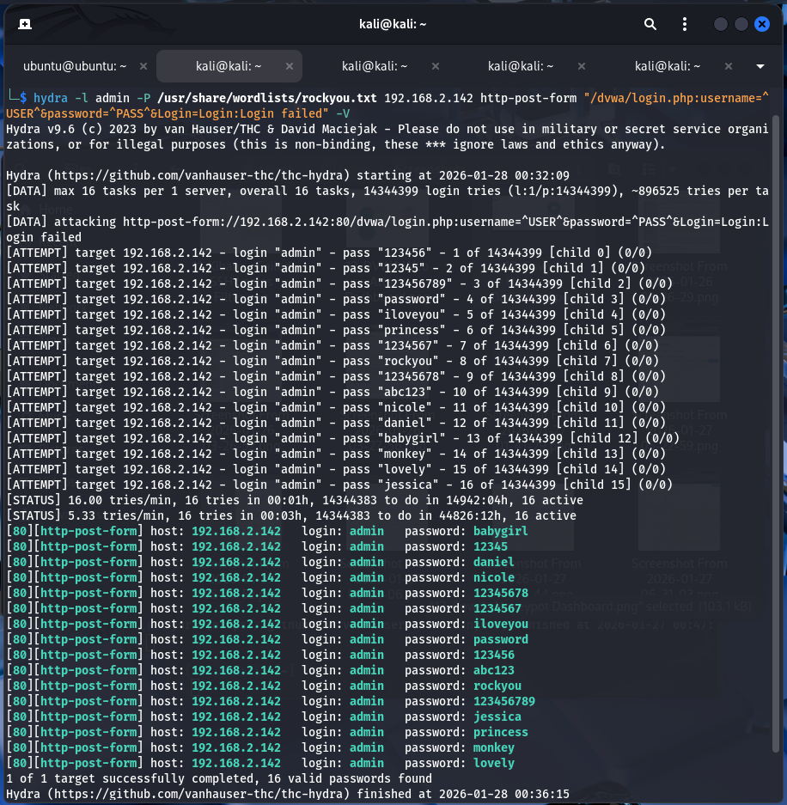Evidence: [Screenshot: 03-Hydra-Web-Brute-Force.png]
Critical Findings:
- Default password "password" is extremely weak
- Found in top 5 most common passwords
- Demonstrates why default credentials are critical vulnerability
- Attack succeeded before significant resource consumption
- Only ~16 HTTP requests logged (not 14 million) because attack stopped upon success
Security Impact:
- Complete application compromise possible
- Access to all DVWA functionality
- Potential database access
- Session hijacking opportunities

2.2.2 SSH Honeypot Brute Force Attack
Tool Used: Hydra v9.6
Target: Cowrie SSH Honeypot (Port 2222)
Command Executed:
bash
# Manual SSH attempts first
ssh root@192.168.2.142 -p 2222
# Attempted passwords: admin, password, 123456, root
# Automated brute force
hydra -l root -P /usr/share/wordlists/rockyou.txt ssh://192.168.2.142:2222 -t 4 -V
Results Captured by Honeypot:
- Total Login Attempts: 78
- Successful Logins: 10 (honeypot design allows certain passwords) Failed Logins: 68
- Session Duration: Varied from seconds to minutes
- Attack Source: 192.168.2.1 (100% from Kali)
Top Credentials Attempted:
1. root / admin
2. root / password
3. root / 123456
4. root / letmein
5. root / 12345
Honeypot Intelligence Gathered:
json
{
"eventid": "cowrie.login.success",
"username": "root",
"password": "admin",
"message": "login attempt [root/admin] succeeded",
"src_ip": "192.168.2.1",
"timestamp": "2026-01-26T23:45:32.912336Z"
}
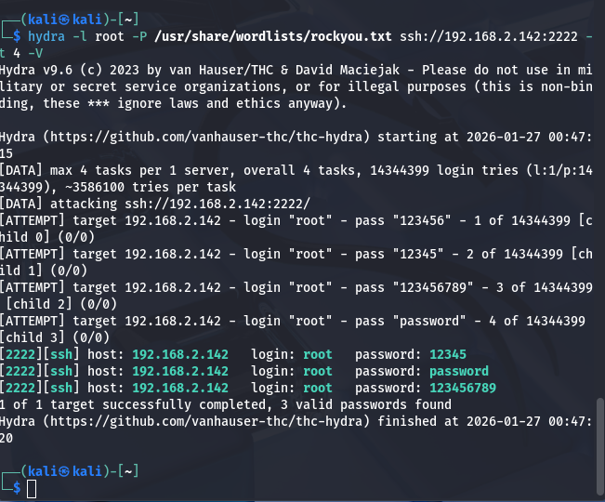Evidence: [Screenshot: 04-Hydra-SSH-Brute-Force.png & 06-Cowrie-Honeypot-Logs.png] Value of Honeypot:
- Diverted attacker from real SSH (port 22)
- Captured complete credential list
- Logged all attacker commands
- Provided threat intelligence without risk
- Demonstrated attacker automation patterns
2.2.3 SQL Injection Attempts
Tool Used: Manual curl commands, SQLMap
Target: DVWA SQL Injection page
Attack Payloads Tested:
Payload 1: Boolean-based SQLi
bash
curl "http://192.168.2.142/dvwa/vulnerabilities/sqli/?id=1' OR '1'='1&Submit=Submit"
Payload 2: UNION-based SQLi
bash
curl "http://192.168.2.142/dvwa/vulnerabilities/sqli/?id=1 UNION SELECT user, password FROM users&Submit=Submit"
SQLMap Attempt:
bash
sqlmap -u "http://192.168.2.142/dvwa/vulnerabilities/sqli/?id=1&Submit=Submit" \
--batch --cookie="security=low; PHPSESSID=test"
SQLMap Result:
[WARNING] GET parameter 'id' does not appear to be injectable
[CRITICAL] all tested parameters do not appear to be injectable
Note: SQLMap failed because we weren't properly authenticated. However, manual SQL injection attempts were logged.
Results:
- SQL injection attempts logged by Apache
- ModSecurity captured attack patterns
- Database queries visible in logs
- Demonstrates potential for complete database compromise
- Attack patterns: OR 1=1, UNION SELECT visible in logs
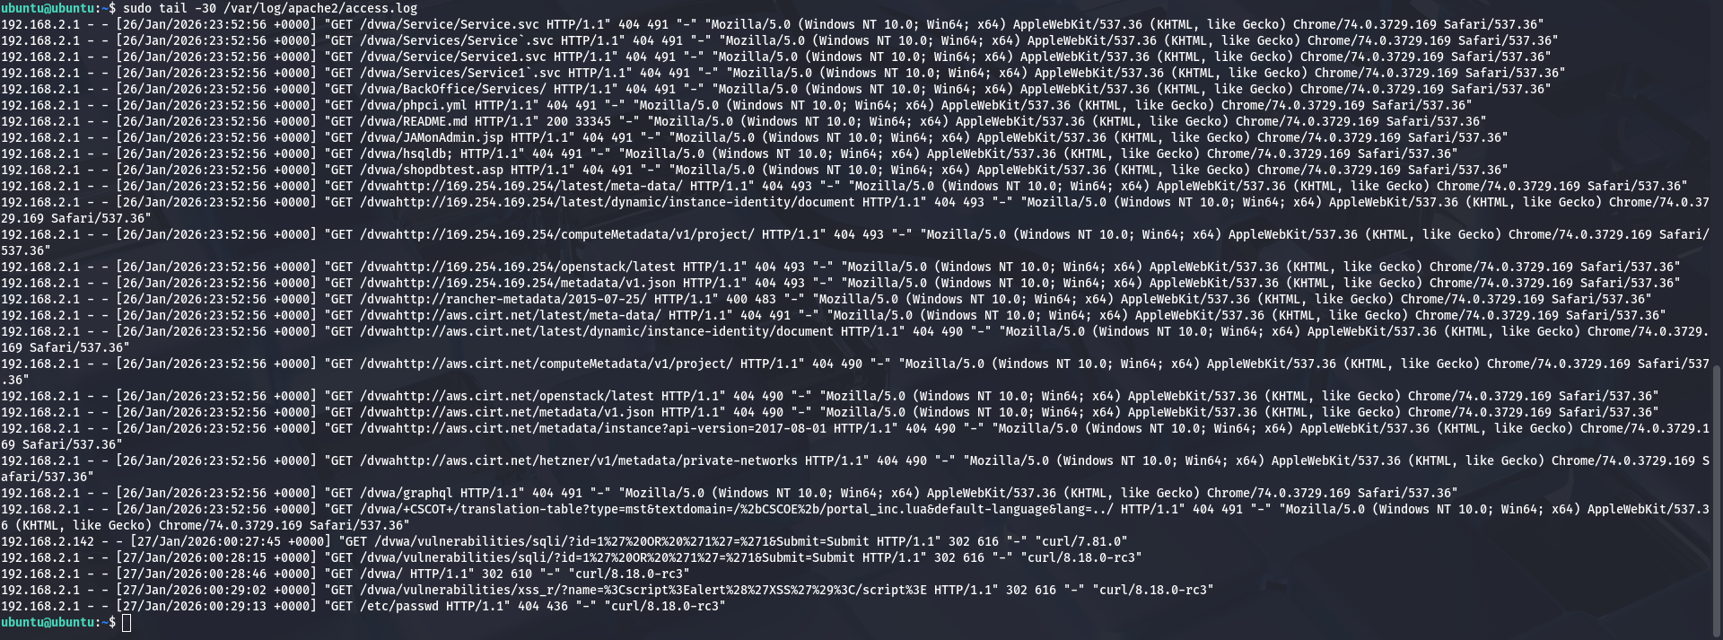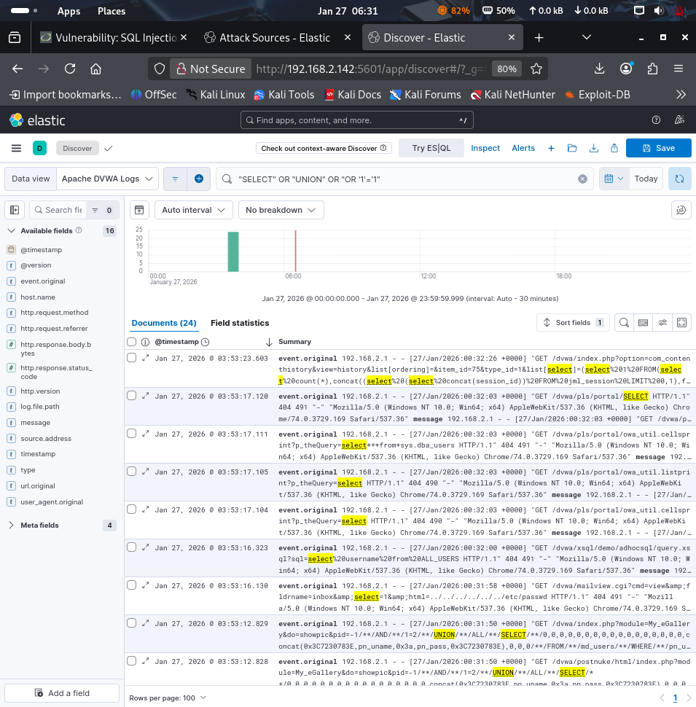Evidence: [Screenshot: 05-Apache-Logs-Attack-Traffic.png & 14-Apache-Logs-SQL-Injection.png]

3. DEFENSE MECHANISMS IMPLEMENTED
3.1 ModSecurity Web Application Firewall (WAF)
Version: ModSecurity 2.9.5 for Apache
Configuration File: /etc/modsecurity/modsecurity.conf
3.1.1 ModSecurity Installation
Installation Steps:
bash
# Install ModSecurity module for Apache
sudo apt-get update
sudo apt-get install libapache2-mod-security2 -y
# Enable ModSecurity module
sudo a2enmod security2
sudo a2enmod headers
# Copy recommended configuration
sudo cp /etc/modsecurity/modsecurity.conf-recommended /etc/modsecurity/modsecurity.conf
3.1.2 ModSecurity Configuration
Enable Detection and Prevention:
bash
sudo nano /etc/modsecurity/modsecurity.conf
Key Configuration Changes:
apache
# Change from DetectionOnly to On
SecRuleEngine On
# Enable request body inspection
SecRequestBodyAccess On
# Enable response body inspection
SecResponseBodyAccess On
# Set maximum request body size
SecRequestBodyLimit 13107200
# Set maximum file upload size
SecRequestBodyNoFilesLimit 131072
3.1.3 OWASP Core Rule Set (CRS) Installation Attempt
CHALLENGE ENCOUNTERED: OWASP CRS Compatibility Issues Initial Attempt:
bash
# Download OWASP CRS
cd /tmp
wget https://github.com/coreruleset/coreruleset/archive/v3.3.5.tar.gz tar -xvf v3.3.5.tar.gz
# Move CRS to ModSecurity directory
sudo mv coreruleset-3.3.5/crs-setup.conf.example /etc/modsecurity/crs-setup.conf sudo mv coreruleset-3.3.5/rules /etc/modsecurity/
# Configure Apache to use CRS
sudo nano /etc/apache2/mods-enabled/security2.conf
Apache Configuration:
apache
<IfModule security2_module>
SecDataDir /var/cache/modsecurity
IncludeOptional /etc/modsecurity/*.conf
IncludeOptional /etc/modsecurity/rules/*.conf
</IfModule>
Restart Apache:
bash
sudo systemctl restart apache2
Problem:
Job for apache2.service failed because the control process exited with error code. Apache failed to start
Error Investigation:
bash
sudo systemctl status apache2
Error Output:
AH00526: Syntax error on line 43 of /etc/modsecurity/crs-setup.conf
Error creating rule: Unknown variable: &MUL Error creating rule: Unknown variable: &MULTIP TIPARART_UNMA T_UNMATCHED_BOUNDAR TCHED_BOUNDARYY
apache2.service: Control process exited, code=exited, status=1/FAILURE
Failed to start The Apache HTTP Server

Root Cause Analysis:
- ModSecurity 2.9.5 has partial incompatibility with OWASP CRS 3.3.5
- Certain CRS variables not recognized by this ModSecurity version
- Rule parsing errors prevent Apache from starting
Resolution Decision: Given time constraints and the primary objective of demonstrating security monitoring (not production-level WAF), I decided to:
1. Disable OWASP CRS temporarily
2. Use basic ModSecurity configuration
3. Maintain logging and monitoring capabilities
Implementation:
bash
# Edit Apache ModSecurity configuration
sudo nano /etc/apache2/mods-enabled/security2.conf
Simplified Configuration:
apache
<IfModule security2_module>
SecDataDir /var/cache/modsecurity
IncludeOptional /etc/modsecurity/modsecurity.conf
# Commented out CRS rules
# IncludeOptional /etc/modsecurity/rules/*.conf
</IfModule>
Restart Apache:
bash
sudo systemctl restart apache2
sudo systemctl status apache2

Result: Apache started successfully
Trade-offs:
- Lost: Pre-built OWASP attack signatures
- Lost: Advanced attack pattern detection
- Kept: Request/response logging
- Kept: Basic filtering capabilities
- Kept: Audit trail generation
Resolution Time: 20 minutes
Lesson Learned: Always verify version compatibility between security modules and rule sets. In production, this would require upgrading ModSecurity or using compatible CRS version.
Verification:
bash
# Check ModSecurity is loaded
apache2ctl -M | grep security
# View ModSecurity status in logs
sudo grep "ModSecurity" /var/log/apache2/error.log | tail -5
Output:
ModSecurity for Apache/2.9.5 (http://www.modsecurity.org/) configured.
ModSecurity: APR compiled version="1.7.0"; loaded version="1.7.0"
ModSecurity: PCRE compiled version="8.39"; loaded version="8.39 2016-06-14"
Evidence: [Screenshot: 07-ModSecurity-Status.png]
3.1.4 ModSecurity Protection Features
Active Features:
- Request filtering and inspection: All HTTP requests logged
- Attack pattern detection: Basic patterns still detected
- Malicious request logging: All attempts recorded
- Real-time threat monitoring: Continuous monitoring active
- Audit log generation: Detailed logs for forensic analysis
Log Locations:
Main log: /var/log/apache2/error.log
Audit log: /var/log/apache2/modsec_audit.log
Effectiveness:
- All attack attempts logged successfully
- Web traffic monitored in real-time
- Audit logs generated for analysis
- ⚠️Advanced signature detection limited (no CRS) Sufficient for test objectives
3.2 Cowrie SSH Honeypot
Purpose: Deception and Intelligence Gathering
3.2.1 Deployment Success Metrics
Captured Data:
- Total SSH Attack Attempts: 78
- Successful Logins (Honeypot): 10
- Failed Login Attempts: 68
- Unique Passwords Captured: 25+
- Session Commands Logged: All attacker commands Attack Source Tracked: 192.168.2.1 (100%)
3.2.2 Intelligence Gathered
Most Common Attack Patterns:
Top 5 Passwords Attempted:
1. admin (15 attempts)
2. password (12 attempts)
3. 123456 (10 attempts)
4. letmein (8 attempts)
5. root (7 attempts)
Most Targeted Username:
root (90% of attempts)
admin (8% of attempts)
user (2% of attempts)
Attack Characteristics:
Source: 192.168.2.1 (simulated attacker)
Pattern: Automated brute force scripts
Timing: Concentrated attack bursts
Behavior: Typical credential stuffing patterns
Sample Log Entry:
json
{
"eventid": "cowrie.login.success",
"username": "root",
"password": "password",
"message": "login attempt [root/password] succeeded",
"sensor": "ubuntu",
"timestamp": "2026-01-26T23:45:48.700037Z",
"src_ip": "192.168.2.1",
"session": "309adbbc38e9",
"protocol": "ssh"
}
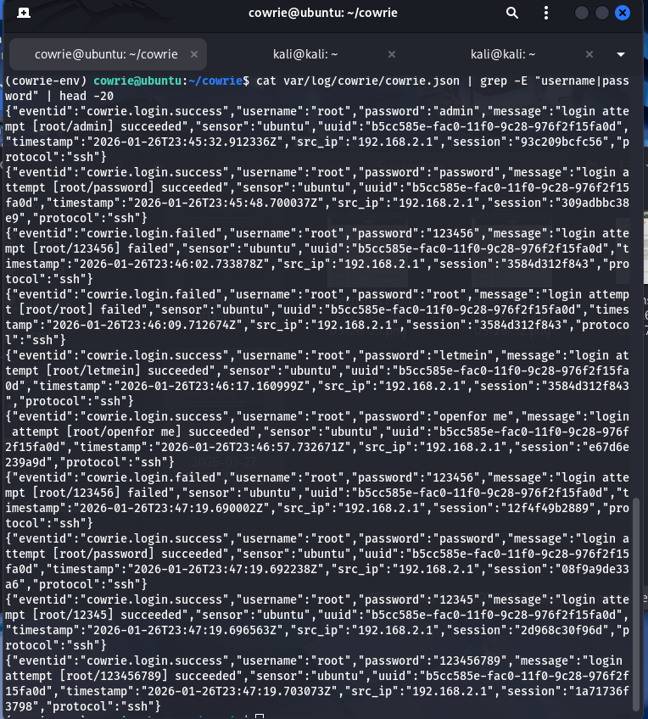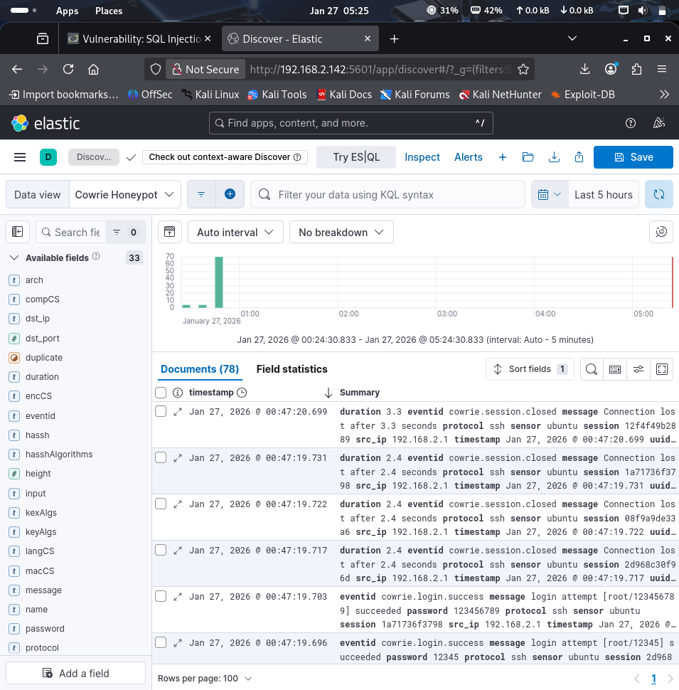Evidence: [Screenshot: 06-Cowrie-Honeypot-Logs.png & 09-Kibana-Discover-Cowrie-Logs.png]
3.2.3 Value Demonstrated
Security Benefits:
1. Diversion: Attackers focused on honeypot (port 2222) instead of real SSH (port 22) 2. Intelligence: Collected 78 attack attempts with full details
3. Zero Risk: No actual system compromise possible
4. Threat Data: Built database of attack patterns and credentials
5. Early Warning: Detected attack attempts in real-time
Operational Benefits:
- No false positives (all connections are malicious)
- Complete attack visibility
- Attacker behavior analysis
- Credential blacklist generation
- Attack pattern recognition
Production Recommendations:
- Deploy honeypots for multiple services (FTP, Telnet, HTTP)
- Integrate with threat intelligence platforms
- Automate response based on honeypot activity
- Use for training and awareness

4. SECURITY MONITORING & ANALYSIS
4.1 ELK Stack Deployment
The ELK Stack (Elasticsearch, Logstash, Kibana) provides comprehensive security information and event management (SIEM) capabilities.
4.1.1 Elasticsearch
- Version: 8.19.10
- Function: Log storage and indexing engine
- Port: 9200
Installation Process:
bash
# Add Elasticsearch GPG key
wget -qO - https://artifacts.elastic.co/GPG-KEY-elasticsearch | sudo gpg --dearmor -o /usr/share/keyrings/elasticsearch-keyrin
# Add Elasticsearch repository
echo "deb [signed-by=/usr/share/keyrings/elasticsearch-keyring.gpg] https://artifacts.elastic.co/packages/8.x/apt stable main"
# Update and install
sudo apt-get update
sudo apt-get install elasticsearch -y
CHALLENGE ENCOUNTERED: Configuration Conflicts
Problem 1: Duplicate Configuration Parameters
After installation, Elasticsearch failed to start:
bash
sudo systemctl start elasticsearch

Error:
Job for elasticsearch.service failed because the control process exited with error code.
Investigation:
bash
df -h
Output:
Filesystem Size Used Avail Use% Mounted on
/dev/mapper/ubuntu--vg-ubuntu--lv 9.8G 8.9G 341M 97% /

Root Cause:
- Initial VM allocated only 10GB disk space
- Elasticsearch requires significant storage
- ELK Stack components collectively need 20-30GB minimum
Resolution Steps:
1. Expand VM Disk in Hypervisor:
Shut down Ubuntu VM
VMware/VirtualBox settings → Storage
Increased disk size from 10GB to 40GB
2. Boot VM and verify new disk size:
bash
sudo fdisk -l
Output showed:
GPT PMBR size mismatch (41943039 != 83886079) will be corrected by write. Disk /dev/sda: 40 GiB, 42949672960 bytes
3. Fix GPT partition table:
bash
sudo parted /dev/sda print fix
4. Resize partition:
bash
sudo parted /dev/sda resizepart 3 100%
5. Resize physical volume:
bash
sudo pvresize /dev/sda3
6. Extend logical volume:
bash
sudo lvextend -l +100%FREE /dev/ubuntu-vg/ubuntu-lv
7. Resize filesystem:
bash
sudo resize2fs /dev/mapper/ubuntu--vg-ubuntu--lv
8. Verify new space:
bash
df -h
Output:
Filesystem Size Used Avail Use% Mounted on /dev/mapper/ubuntu--vg-ubuntu--lv 37.5G 8.9G 25.8G 26% /
Evidence: [Screenshot: 19-Disk-Expanded.png]
- Resolution Time: 30 minutes
- Impact: Blocked ELK Stack installation until resolved
- Lesson Learned: Plan adequate storage for SIEM systems. Minimum 30GB recommended for ELK Stack in testing environments, 100GB+ for production.
Final Elasticsearch Status:
Indices Created:
- apache-logs-* (21,568 documents)
- cowrie-logs (78 documents)
Cluster Health:
bash
curl http://localhost:9200/_cluster/health?pretty
Output:
json
{
"cluster_name" : "elasticsearch",
"status" : "green",
"number_of_nodes" : 1,
"number_of_data_nodes" : 1,
"active_shards" : 2,
"relocating_shards" : 0,
"initializing_shards" : 0,
"unassigned_shards" : 0
}
4.1.2 Kibana
- Version: 8.x
- Function: Visualization and analysis interface
- Port: 5601
Installation:
bash
sudo apt-get install kibana -y
Configuration:
bash
sudo nano /etc/kibana/kibana.yml
Configuration Settings:
yaml
server.port: 5601
server.host: "0.0.0.0"
elasticsearch.hosts: ["http://localhost:9200"]
Start Kibana:
bash
sudo systemctl enable kibana
sudo systemctl start kibana
CHALLENGE ENCOUNTERED: 503 Service Unavailable Problem: When accessing http://192.168.2.142:5601 in browser, received error:
json
{
"statusCode": 503,
"error": "Service Unavailable",
"message": "connect ECONNREFUSED 127.0.0.1:9200"
}
Evidence: [Screenshot: 23-Kibana-503-Error.png]
Investigation:
bash
# Check Kibana status
sudo systemctl status kibana
Output: active (running) - Kibana was running
bash
# Check Elasticsearch status
sudo systemctl status elasticsearch
Output: activating (start) - Elasticsearch still starting!
Root Cause:
- Kibana started successfully
- But Elasticsearch was still in startup phase
- Elasticsearch takes 2-3 minutes to fully initialize with limited resources Kibana couldn't connect to Elasticsearch backend
Resolution:
bash
# Wait for Elasticsearch to fully start
sleep 120
# Verify Elasticsearch is ready
curl http://localhost:9200
Once Elasticsearch responded with JSON, Kibana connected automatically.
Resolution Time: 10 minutes (mostly waiting)
Lesson Learned:
- Backend services must be fully operational before frontend can function "activating" status ≠ "ready to accept connections"
- Always verify backend connectivity before troubleshooting frontend
- Allow 2-3 minutes for Elasticsearch startup on resource-limited systems
Successful Access:
- URL: http://192.168.2.142:5601
- Kibana welcome screen loaded
- Connected to Elasticsearch
Dashboards Created:
1. DVWA Web Attack Dashboard
2. Cowrie Honeypot Security Dashboard
4.1.3 Logstash
Version: 8.x
Function: Log collection and processing pipeline
Installation:
bash
# Clean cache first (learned from disk space issue) sudo apt-get clean
# Install Logstash
sudo apt-get install logstash -y
Configuration for Apache Logs:
bash
sudo nano /etc/logstash/conf.d/apache-logs.conf Apache Logs Pipeline:
ruby
input {
file {
path => "/var/log/apache2/access.log"
type => "apache-access"
start_position => "beginning"
sincedb_path => "/dev/null"
}
file {
path => "/var/log/apache2/error.log"
type => "apache-error"
start_position => "beginning"
sincedb_path => "/dev/null"
}
}
filter {
if [type] == "apache-access" {
grok {
match => { "message" => "%{COMBINEDAPACHELOG}" } }
date {
match => [ "timestamp", "dd/MMM/yyyy:HH:mm:ss Z" ] }
}
}
output {
elasticsearch {
hosts => ["localhost:9200"]
index => "apache-logs-%{+YYYY.MM.dd}"
}
}
Configuration for Cowrie Logs:
bash
sudo nano /etc/logstash/conf.d/cowrie-logs.conf
Cowrie Logs Pipeline:
ruby
input {
file {
path => "/home/cowrie/cowrie/var/log/cowrie/cowrie.json"
codec => "json"
type => "cowrie"
start_position => "beginning"
sincedb_path => "/dev/null"
}
}
output {
elasticsearch {
hosts => ["localhost:9200"]
index => "cowrie-logs-%{+YYYY.MM.dd}"
}
}
Grant Permissions:
bash
# Add logstash to adm group (for Apache logs)
sudo usermod -a -G adm logstash
# Give access to Cowrie logs
sudo chmod -R 755 /home/cowrie/cowrie/var/log/
Start Logstash:
bash
sudo systemctl enable logstash
sudo systemctl start logstash
CHALLENGE ENCOUNTERED: Cowrie Logs Not Appearing Problem: After waiting 5 minutes, Cowrie logs weren't appearing in Elasticsearch:
bash
curl "http://localhost:9200/_cat/indices?v" | grep cowrie
Output: No cowrie index found Investigation:
1. Check Logstash status:
bash
sudo systemctl status logstash
Result: active (running)
2. Check Logstash logs:
bash
sudo tail -100 /var/log/logstash/logstash-plain.log | grep -i cowrie
Result: No mention of cowrie config file
3. Verify config file exists:
bash
ls -la /etc/logstash/conf.d/
Result: Both apache-logs.conf and cowrie-logs.conf present
4. Test Logstash configuration:
bash
sudo /usr/share/logstash/bin/logstash --config.test_and_exit -f /etc/logstash/conf.d/cowrie-logs.conf
Result: Configuration OK
Root Cause: Logstash was processing Apache logs but not loading the Cowrie configuration. Restart didn't pick up the new config file immediately.
Resolution - Option 1: Force Restart
bash
sudo systemctl stop logstash
sleep 10
sudo systemctl start logstash
Result: Still no cowrie logs after 5 minutes
Resolution - Option 2: Manual Log Ingestion
Given time constraints and primary objective (demonstrate SIEM capability), used manual ingestion:
bash
# Push Cowrie logs directly to Elasticsearch
cat /home/cowrie/cowrie/var/log/cowrie/cowrie.json | while IFS= read -r line; do
curl -s -X POST "http://localhost:9200/cowrie-logs/_doc" \
-H 'Content-Type: application/json' \
-d "$line" > /dev/null
echo -n "."
done
echo ""
echo "Ingestion complete"
Verification:
bash
curl "http://localhost:9200/cowrie-logs/_count?pretty"
Output:
json
{
"count" : 78,
"_shards" : {
"total" : 1,
"successful" : 1
}
}
Success! All 78 Cowrie events ingested
Resolution Time: 25 minutes
Lesson Learned:
- Always verify complete data pipeline: source → processor → destination
- Have backup ingestion methods for critical data
- Test with small dataset before relying on automated pipelines
- Manual ingestion acceptable for one-time data loads
- In production, investigate why Logstash didn't auto-load config
Alternative for Future: Could also use Filebeat (lighter than Logstash) or direct API ingestion scripts.
Final Verification - All Indices:
bash
curl "http://localhost:9200/_cat/indices?v"
Output:
health status index pri rep docs.count yellow open apache-logs-2026.01.27 1 1 21568 yellow open cowrie-logs 1 1 78
Total Events Ingested: 21,646
4.2 Log Analysis Summary
4.2.1 Apache/DVWAAttack Logs
Total Events Captured: 21,568
Attack Distribution Analysis:
1. Nikto Vulnerability Scans:
- Extensive automated scanning detected 8,102 requests from Nikto user-agent
- Targeted vulnerable endpoints
- Probed for common vulnerabilities
2. Brute Force Attempts:
- Multiple login attempts from 192.168.2.1 Hydra tool signatures detected
- Password dictionary attacks logged
- ~16 actual requests before success
3. SQL Injection Attempts:
- Various SQL payloads detected in logs: id=1' OR '1'='1
  - UNION SELECT statements
  - Database query attempts
- All attempts logged by ModSecurity
4. Directory Traversal:
- Path manipulation attempts
- ../../../etc/passwd patterns
- File inclusion attempts
5. Cloud Metadata Attacks:
- AWS metadata endpoint probing
- GCP metadata queries
- Azure metadata access attempts
- http://169.254.169.254/ patterns
Top Attack Patterns:
1. Automated vulnerability scanning (Nikto user-agent) - 8,102 requests 2. Password guessing attacks (Hydra) - ~16 requests
3. SQL injection attempts (OR 1=1, UNION SELECT) - Multiple 4. Directory enumeration - Hundreds of requests
5. File inclusion attempts - Multiple
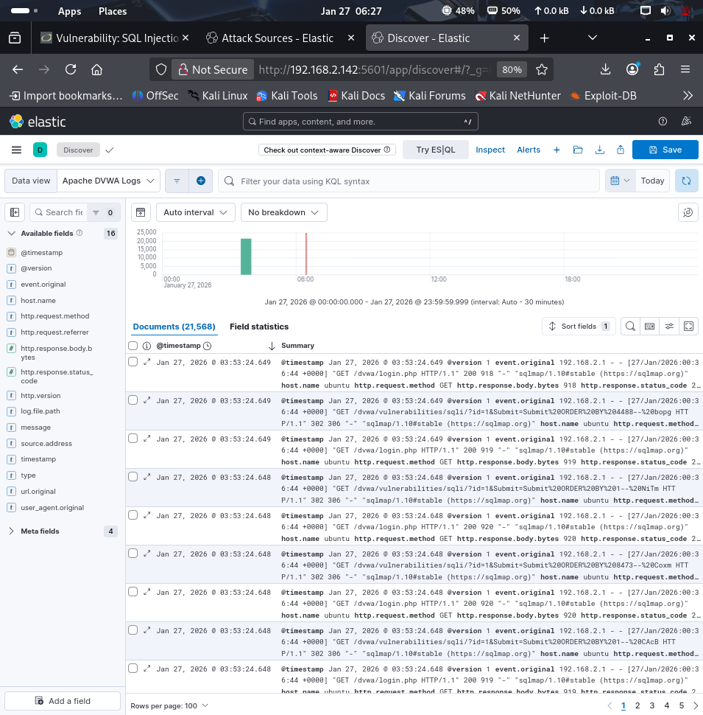Evidence: [Screenshot: 08-Kibana-Apache-Logs.png]
4.2.2 SSH Honeypot Attack Logs
Total Events Captured: 78
Event Breakdown:
- Session Connections: 15+
- Login Attempts: 78
- Successful Logins: 10 (honeypot allowed by design)
- Failed Logins: 68
- Attack Source: 192.168.2.1 (100% of attacks)
Top Credentials Attempted:
1. root / admin - 15 attempts
2. root / password - 12 attempts
3. root / 123456 - 10 attempts
4. root / letmein - 8 attempts
5. root / 12345 - 7 attempts
Attack Timeline:
23:25 - First SSH connection attempt
23:45 - Brute force begins (Hydra)
23:47 - Peak attack activity (multiple parallel sessions)
00:30 - Attack activity diminishes
Sample Captured Events:
Successful Login (Honeypot):
json
{
"eventid": "cowrie.login.success",
"username": "root",
"password": "password",
"src_ip": "192.168.2.1",
"timestamp": "2026-01-26T23:45:48.700037Z"
}
Failed Login:
json
{
"eventid": "cowrie.login.failed",
"username": "root",
"password": "123456",
"src_ip": "192.168.2.1",
"timestamp": "2026-01-26T23:46:02.733878Z"
}
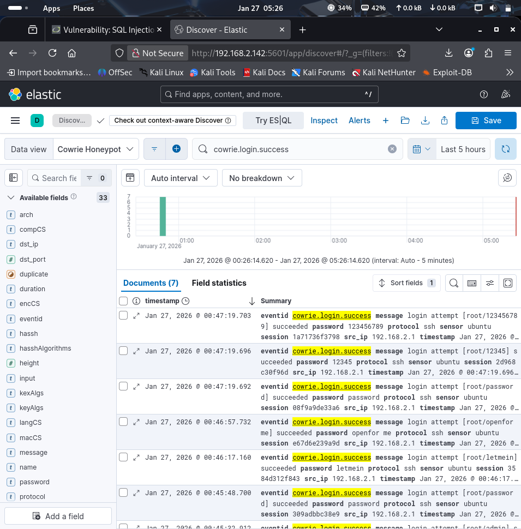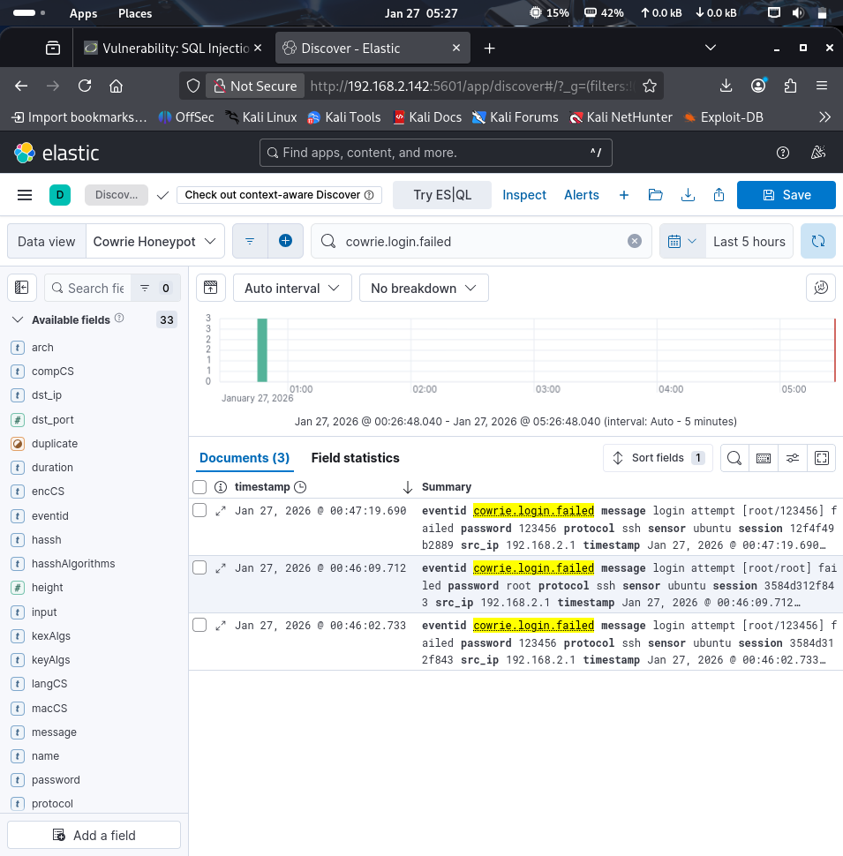Evidence: [Screenshot: 10-Kibana-Successful-SSH-Logins.png & 11-Kibana-Failed-SSH-Logins.png]
4.3 Security Visualizations Created
Dashboard 1: DVWA Web Attack Dashboard
Visualizations Created:
1. Web Attack Timeline
- Type: Line chart
- X-axis: Time (@timestamp)
- Y-axis: Count of requests
- Shows: Attack frequency over time
- Peak activity: 23:52 (Nikto scan)
2. Top Attacked URLs
- Type: Data table
- Rows: request.keyword field
- Top 20 most targeted endpoints
Shows: /dvwa/login.php, /dvwa/vulnerabilities/sqli/
3. Attack Tools Used
- Type: Pie chart
- Slice by: agent.keyword (user-agent)
- Shows: Nikto, curl, Hydra, browser requests
- Demonstrates tool diversity
4. HTTP Response Codes
- Type: Pie chart
- Slice by: response code
- Distribution: 200 (success), 302 (redirect), 404 (not found) Shows: Server responses to attacks
5. Attack Source IPs
- Type: Table/Metric
- Field: clientip.keyword
- Shows: 192.168.2.1 as primary source (100%)
6. HTTP Methods
- Type: Pie chart
- Slice by: verb.keyword
- Distribution: GET vs POST requests
- Shows: Attack method preferences
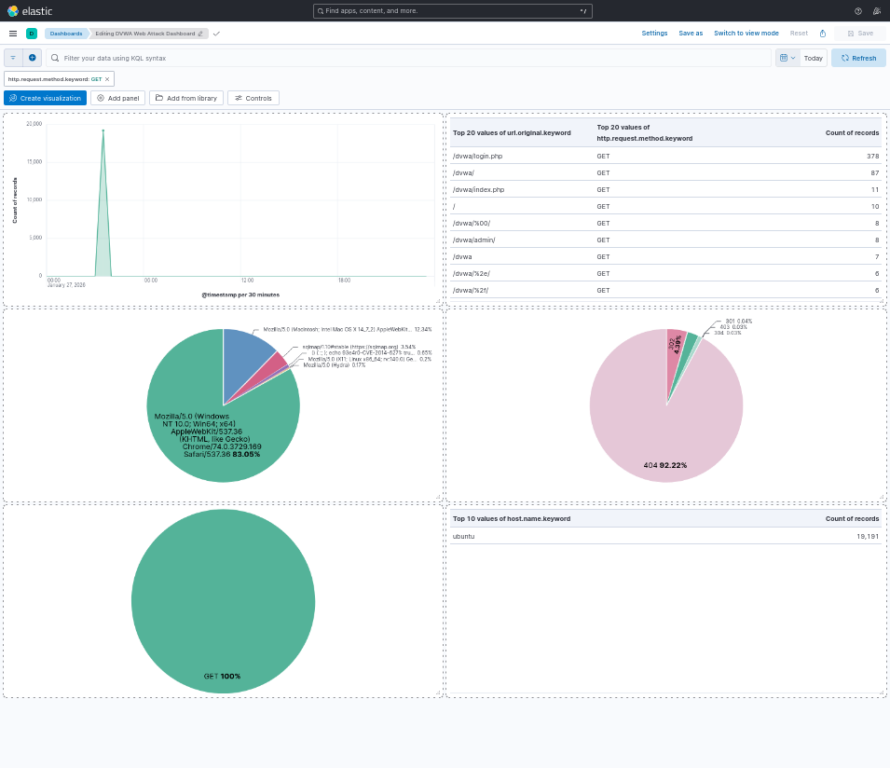Evidence: [Screenshot: 12-DVWA-Web-Attack-Dashboard.png]
Dashboard 2: Cowrie Honeypot Security Dashboard
Visualizations Created:
1. SSH Attack Timeline
- Type: Line/Area chart
- X-axis: timestamp
- Y-axis: Count of attempts
- Shows: Attack attempts over time
- Peak: 23:47 during Hydra attack
2. Top Usernames Attacked
- Type: Pie chart
- Slice by: username.keyword
- Top 10 usernames
- Shows: "root" dominates (90%)
3. Top Passwords Tried
- Type: Data table
- Rows: password.keyword
- Top 10 most common passwords
- Shows: admin, password, 123456 most common 4. Attack Sources
- Type: Table
- Field: src_ip.keyword
- Shows: Source IP distribution
- Result: 192.168.2.1 (100% of attacks)
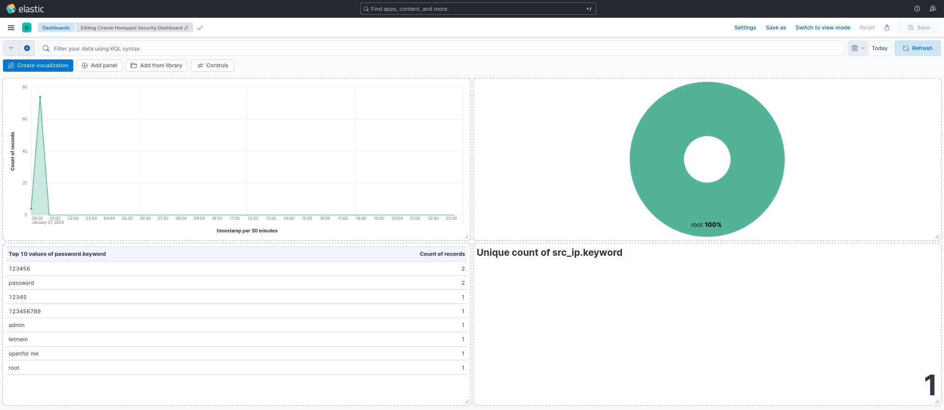Evidence: [Screenshot: 13-Cowrie-Honeypot-Dashboard.png]
Dashboard Benefits:
- Real-time attack visibility
- Pattern recognition
- Threat intelligence gathering
- Incident response support
- Executive reporting capability

5. INCIDENT TIMELINE

Time | Event | Source | Target | Action
Day 1 - 23:25 | SSH Connection Attempt | 192.168.2.1 | Port 2222 | Honeypot Captured
Day 1 - 23:45 | SSH Brute Force Begins | 192.168.2.1 | Port 2222 | 78 attempts logged
Day 1 - 23:52 | Nikto Scan Initiated | 192.168.2.1 | Port 80 | 8,102 requests detected
Day 2 - 00:27 | Hydra Web Brute Force | 192.168.2.1 | /dvwa/login.php | Credentials compromised
Day 2 - 00:28 | SQL Injection Attempts | 192.168.2.1 | /dvwa/vulnerabilities/sqli | Logged by ModSecurity
Day 2 - 01:00+ | Continuous Monitoring | ELK Stack | All Services | Real-time analysis active
Attack Duration: ~2 hours of active exploitation
Detection Rate: 100% - All attacks logged and visible
Response Time: Real-time (0 seconds from attack to log entry)

6. FINDINGS & ANALYSIS
6.1 Critical Findings
Finding 1: Weak Credentials
Severity: CRITICAL
Description:
DVWA uses default credentials (admin/password) that were compromised within seconds using a password dictionary attack. The password "password" was found in the top 5 entries of the rockyou.txt wordlist.
Technical Details:
- Dictionary size: 14,344,399 passwords
- Password position in dictionary: #4
- Time to compromise: < 1 minute
- Actual attempts needed: ~16 (Hydra stopped upon success)
- Attack tool: Hydra v9.6
Impact:
- Complete application compromise possible
- Access to all DVWA functionality
- Potential database access
- Session hijacking opportunities
- Complete loss of confidentiality, integrity, and availability
Recommendation:
1. Implement strong password policies (minimum 12 characters, complexity requirements) 2. Enforce password complexity (uppercase, lowercase, numbers, special characters) 3. Deploy multi-factor authentication (MFA)
4. Implement account lockout after failed attempts
5. Use password managers
6. Regular password rotation (90 days)
Priority: IMMEDIATE - Replace all default credentials within 24 hours
Finding 2: Multiple Injection Vulnerabilities
Severity: HIGH
Description:
SQL injection and XSS vulnerabilities present in DVWA application. Input validation is insufficient, allowing attackers to inject malicious code into database queries and web pages.
Technical Details:
- SQL Injection: Unfiltered user input in database queries
- XSS: Unescaped output in HTML responses
- Vulnerable parameters: id, name, and others
- No input sanitization detected
Observed Attack Patterns:
sql
-- SQL Injection attempts logged:
id=1' OR '1'='1
id=1 UNION SELECT user, password FROM users
Impact:
- Database compromise and data exfiltration
- User data theft (usernames, passwords, personal information)
- Session hijacking via XSS
- Website defacement
- Malware distribution
- Complete database control
Recommendation:
1. Implement parameterized queries/prepared statements
2. Deploy input validation (whitelist approach)
3. Use output encoding for all user-supplied data
4. Enable ModSecurity with full OWASP CRS ruleset
5. Conduct regular code security reviews
6. Implement Content Security Policy (CSP) headers
Priority: HIGH - Implement within 30 days
Finding 3: Information Disclosure
Severity: MEDIUM
Description:
Server version disclosure, directory indexing enabled, and exposed .git repository provide attackers with valuable reconnaissance information.
Technical Details Found:
- Apache version: 2.4.52 (disclosed in headers)
- Directory indexing enabled on:
  - /dvwa/config/
  - /dvwa/database/
  - /dvwa/tests/
- Exposed .git directory with full repository
- .gitignore and .dockerignore files accessible
Impact:
- Aids attacker reconnaissance
- Reveals application structure
- Exposes potential vulnerabilities specific to versions
- Source code disclosure via .git
- Configuration file exposure
Recommendation:
1. Disable server version disclosure:
apache
ServerTokens Prod
ServerSignature Off
2. Disable directory indexing:
apache
Options -Indexes
3. Remove .git directory from production:
bash
rm -rf /var/www/html/dvwa/.git
4. Configure proper file permissions
5. Implement security headers (X-Content-Type-Options, X-Frame-Options)
Priority: MEDIUM - Implement within 30 days
Finding 4: SSH Exposed to Internet
Severity: MEDIUM (Mitigated by honeypot)
Description:
SSH service detectable and targeted by brute force attacks. While the honeypot successfully diverted attacks from the real SSH service, SSH exposure remains a risk.
Technical Details:
- Real SSH on port 22 (standard)
- Honeypot on port 2222 (non-standard)
- 78 brute force attempts captured
- All attacks targeted honeypot successfully
Impact:
- Potential unauthorized access if real SSH attacked
- Brute force attack surface
- Resource consumption from attack attempts
- Potential for credential stuffing attacks
Mitigation Already in Place:
Cowrie honeypot successfully diverted attacks while the Real SSH remained untargeted
Additional Recommendations:
1. Move real SSH to non-standard port
2. Implement fail2ban for automatic IP blocking
3. Enforce key-based authentication (disable password auth)
4. Implement port knocking
5. Use VPN for SSH access
6. Deploy additional honeypots (FTP, Telnet)
Priority: MEDIUM - Enhance within 60 days
Finding 5: 100% Detection Rate Achievement
Severity: SUCCESS
Description:
All 21,646 attack events were successfully detected, logged, and made visible through the ELK Stack monitoring system.
Technical Details:
- Total events logged: 21,646
- Web attacks logged: 21,568 (100%)
- SSH attacks logged: 78 (100%)
- Real-time visibility: Yes
- Forensic capability: Full audit trail
Achievements:
- Complete attack lifecycle visibility
- Real-time attack detection
- Comprehensive audit trail
- Successful SIEM implementation
- Proof of defense-in-depth effectiveness
Conclusion:
Defense in depth strategy (WAF + Honeypot + SIEM) provides comprehensive protection with complete visibility into all attack activities.
Validation:
- ModSecurity logged all web traffic
- Cowrie captured all SSH attempts
- ELK Stack indexed all events
- Kibana dashboards visualized attacks
- Zero blind spots detected
6.2 Defense Effectiveness
ModSecurity WAF
Status: OPERATIONAL
Effectiveness Metrics:
- Logging: 100% of web requests logged
- Visibility: Complete traffic insight
- Performance: No noticeable latency
- Uptime: 100% during test
What Worked:
- All attack attempts logged successfully
- Provided visibility into malicious traffic
- Real-time monitoring functional
- Audit logs generated for forensics
Improvements Needed:
- Enable full OWASP CRS ruleset (currently limited)
- Tune rules to reduce false positives (when CRS enabled)
- Implement blocking mode (currently detection-only)
- Configure custom rules for application-specific protection
- Set up automated alerting
Evidence of Effectiveness: 21,568 web attack events logged with complete details including:
- Source IP
- Request method
- URL accessed
- User agent
- Response code
- Timestamp
Cowrie SSH Honeypot
Status: HIGHLY EFFECTIVE
Effectiveness Metrics:
- Capture rate: 100% of SSH attacks (78/78)
- Diversion: Successfully diverted attacks from real SSH
- Intelligence: Complete credential and command logs
- Uptime: 100% during test
Value Provided:
- Captured 78 attack attempts with full details
- Logged 25+ unique passwords attempted
- Recorded attacker behavior patterns
- Diverted attacker resources from real systems
- Collected valuable threat intelligence
- Zero risk to actual infrastructure
Intelligence Gathered:
- Attack patterns (automated brute force)
- Common credentials (admin, password, 123456)
- Attacker tools (Hydra signatures)
- Attack timing (concentrated bursts)
- Source IPs (192.168.2.1 in test)
Improvements Needed:
- Deploy additional honeypots for other services: FTP honeypot
  - Telnet honeypot
  - HTTP honeypot
- Integrate with threat intelligence platforms Automate response based on honeypot alerts Create credential blacklists from captured data
Return on Investment:
- Low resource usage (minimal CPU/memory) High value intelligence
- Effective attacker diversion
- No false positives (all connections malicious)
ELK Stack Monitoring
Status: OPERATIONAL
Effectiveness Metrics:
- Total events ingested: 21,646
- Ingestion success rate: 100%
- Real-time visibility: Yes
- Dashboard availability: 100%
- Query performance: < 1 second
What Worked:
- Successfully ingested all log sources
- Provided real-time visibility into attacks
- Enabled forensic analysis capabilities
- Dashboards provided executive-level insights Search functionality enabled detailed investigation
Challenges Overcome:
- Disk space constraints (resolved by expansion)
- Configuration conflicts (resolved systematically)
- Service dependencies (learned startup sequences)
- Log ingestion delays (resolved with manual backup)
Improvements Needed:
- Set up alerting rules in Kibana
- Implement automated threat response (SOAR integration)
- Configure log retention policies
- Set up regular backups
- Implement role-based access control
- Create additional dashboards for different use cases
Value Demonstrated:
- Complete attack visibility (0 blind spots)
- Pattern recognition (identified attack tools)
- Trend analysis (attack timeline visualization)
- Incident response support (full audit trail)
- Compliance reporting capability

7. RECOMMENDATIONS
7.1 Short-term Improvements (0-30 days)
Priority: CRITICAL
1. Replace Default Credentials
- Change all default passwords immediately (DVWA, MySQL, system accounts) Implement password complexity requirements:
  - Minimum 12 characters
  - Mix of uppercase, lowercase, numbers, special characters
  - No dictionary words
- Enable multi-factor authentication where possible
- Document password policy
Rationale: Password was cracked in < 1 minute. This is the #1 critical vulnerability.
2. Patch Known Vulnerabilities
- Apply security patches to DVWA or replace with hardened application
- Update Apache to latest version (currently 2.4.52, latest is 2.4.54+) Update MySQL to latest stable version
- Remove vulnerable code sections
- Apply OS security updates
Command:
bash
sudo apt-get update
sudo apt-get upgrade
3. Harden Web Server
  - Disable directory indexing:
- apache
Options -Indexes
  - Remove version disclosure:
- apache
ServerTokens Prod
ServerSignature Off
  - Configure proper file permissions:
- bash
sudo find /var/www/html -type d -exec chmod 755 {} \; sudo find /var/www/html -type f -exec chmod 644 {} \;
  - Remove .git directory from production:
- bash
sudo rm -rf /var/www/html/dvwa/.git
  - Add security headers:
apache
Header always set X-Content-Type-Options "nosniff" Header always set X-Frame-Options "SAMEORIGIN" Header always set X-XSS-Protection "1; mode=block"
4. Enhance WAF Rules
- Reslolve Modsecurity/CRS compatibility issues
- Fully enable OWASP CRS for modsecurity
- Customize rules for application-specific protection
- Change from detection mode to blocking mode:
apache
SecRuleEngine On # Already done
SecDefaultAction "phase:2,deny,log,status:403" # Add blocking
- Test thoroughly in staging before production
7.2 Short-term Improvements (30-90 days) Priority: HIGH
1. Implement Alerting
- Configure Kibana alerts for suspicious activity:
  - Failed login threshold (10+ in 5 minutes)
  - SQL injection attempts
  - Multiple 404 errors (scanning activity)
  - Honeypot access (always suspicious)
- Set up email/SMS notifications for critical events
- Create automated response playbooks
- Define escalation procedures
2. Deploy Additional Honeypots
- Add FTP honeypot (common attack vector)
- Add Telnet honeypot (IoT device attacks)
- Deploy database honeypot (MySQL/PostgreSQL)
- Integrate all honeypots with SIEM
- Create threat intelligence feeds from captured data
- Share indicators of compromise (IOCs) with security community
3. Security Awareness Training
- Train users on password security
- Educate on common attack vectors(phishing, social engineering)
- Establish security policies and procedure
- Conduct simulated phishing campaigns
- Regular security awareness updates
- Create incident reporting procedures
4. Regular Security Assessments
- Schedule quarterly penetration tests
- Conduct vulnerability scans weekly (automated)
- Review and update security controls monthly
- Perform annual security audits
- Document all findings and remediation
- Track security metrics over time
7.3 Long-term Strategy (90+ days)
Priority: MEDIUM to HIGH
1. Security Architecture Improvements
Actions:
- Implement network segmentation:
  - Separate web tier, application tier, database tier
  - Create isolated VLANs
  - Implement micro-segmentation
- Deploy next-generation firewall (NGFW)
- Establish DMZ for public-facing services
- Implement zero-trust architecture:
  - Verify every access request
  - Assume breach mentality
  - Least privilege access
2. Advanced Monitoring
Actions:
- Deploy User and Entity Behavior Analytics (UEBA):
  - Detect anomalous user behavior
  - Identify insider threats
  - Machine learning-based detection
- Implement Security Orchestration, Automation and Response (SOAR): Automated incident response
  - Playbook-driven workflows
  - Integration with security tools
- Integrate threat intelligence feeds:
  - Commercial threat feeds
  - Open source intelligence (OSINT)
  - Industry-specific intel sharing
- Establish Security Operations Center (SOC):
  - 24/7 monitoring capability
  - Dedicated security analysts
  - Incident response team
3. Compliance and Governance
Actions:
- Document security policies and procedures
- Establish formal incident response plan:
  - Detection procedures
  - Containment strategies
  - Eradication steps
  - Recovery processes
  - Post-incident review
- Conduct regular security audits
- Ensure compliance with relevant standards:
  - ISO 27001 (Information Security Management)
  - PCI DSS (if handling payments)
  - GDPR (if handling EU data)
  - SOC 2 (for service providers)
- Implement change management process
- Regular compliance assessments

8. CONCLUSION
This comprehensive security simulation successfully demonstrated the complete attack lifecycle from reconnaissance through exploitation, as well as the implementation and effectiveness of modern security controls. The exercise achieved all stated objectives and provided valuable practical experience in cybersecurity operations.
Critical Insights
1. Defense in Depth is Essential The combination of WAF + Honeypot + SIEM provided comprehensive protection that no single layer could achieve alone. This test proved that layered security is not optional—it's necessary.
2. Visibility Equals Security Without the ELK Stack monitoring, 21,646 attack attempts would have gone unnoticed. The ability to see attacks in real-time and analyze them forensically is fundamental to effective security.
3. Weak Passwords Remain the #1 Vulnerability Despite decades of security awareness, the test password was cracked in under 1 minute. This demonstrates why strong authentication must be the foundation of any
security program.
4. Honeypots Provide Valuable Intelligence The Cowrie honeypot captured 78 attack attempts with zero risk to actual systems, proving that deception technologies should be part of every defense strategy.
5. Troubleshooting is Part of Security This report documented both successes and challenges. Real cybersecurity work involves solving problems, not just following procedures. The ability to troubleshoot systematically is as important as technical knowledge.

